Analog Electronic Circuits – Lab 1

*Sricharan Vinoth Kumar*

*Roll No: 2024112022*

Experiment 1:

* Objective
  1. To study the effects of Probe Factor and OSC Factor on the measurement of a voltage response.
  2. To obtain the Fast Fourier Transform of a square wave and analyze the signal before and after passing it through a low-pass filter.
* Components Used:
  + Digital Storage Oscilloscope
  + Resistors
  + Capacitors
  + Breadboard
  + Jumper Cables
* Procedure:
  1. Generate a Sine wave of a certain frequency (say 10kHz) in the DSO and connect the probes of the DSO across it. Vary the probe factors and the OSC factors and measure the amplitude of the wave in each case.
  2. Obtain the FFT of the sine wave.
  3. Generate a Square wave in the DSO and connect the probes of the DSO across it. Obtain the FFT of the signal and measure the strength of the first five harmonics (peaks) of the signal in the FFT.
  4. Now pass the square wave across a RC low-pass filter with a reasonable cutoff frequency depending on the frequency of the square wave and measure the strength of the first five harmonics.

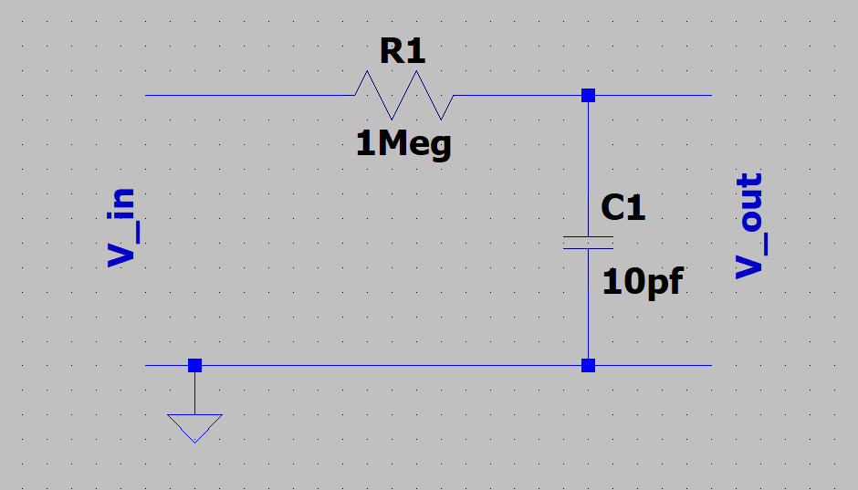

Circuit Diagram of a RC Low Pass Filter

* Observation:
  + - Part 1:

|  |  |  |  |  |  |  |
| --- | --- | --- | --- | --- | --- | --- |
| Type of Signal | Amplitude (V) | Frequency (kHz) | Probe Factor | OSC Factor | Vosc (V) | Vout = OSC/Probe * Vin (V) |
| Sine | 5 | 10 | 1 | 1 | 5.19 | 5 |
| Sine | 5 | 10 | 10 | 1 | 0.519 | 0.5 |
| Sine | 5 | 10 | 1 | 10 | 51.1 | 50 |
| Sine | 5 | 10 | 10 | 10 | 5.19 | 5 |

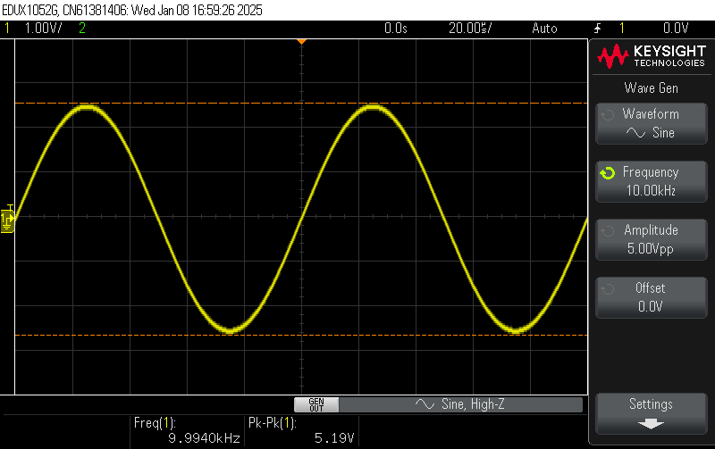

Probe Factor = 1, OSC Factor = 1

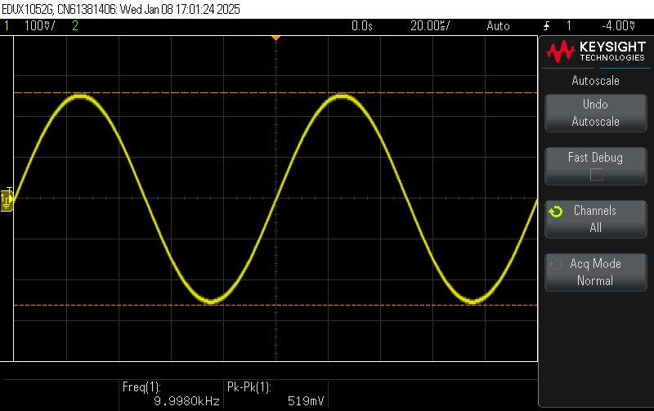

Probe Factor = 10, OSC Factor = 1

Probe Factor = 1, OSC Factor = 10

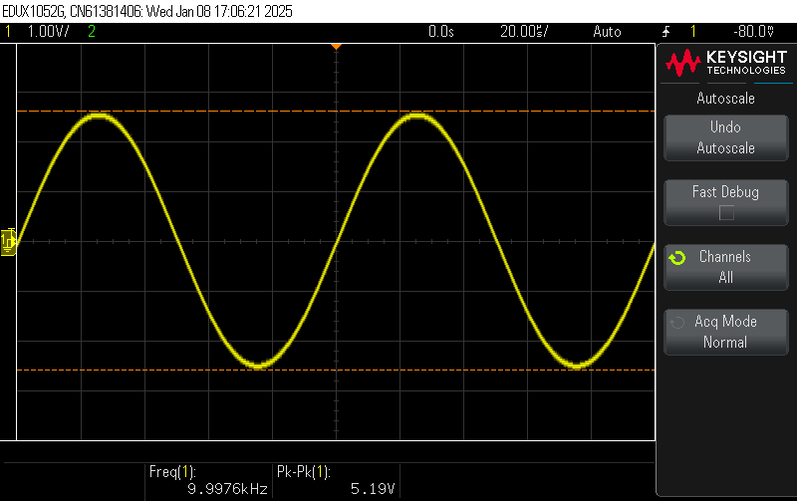

Probe Factor = 10, OSC Factor = 10

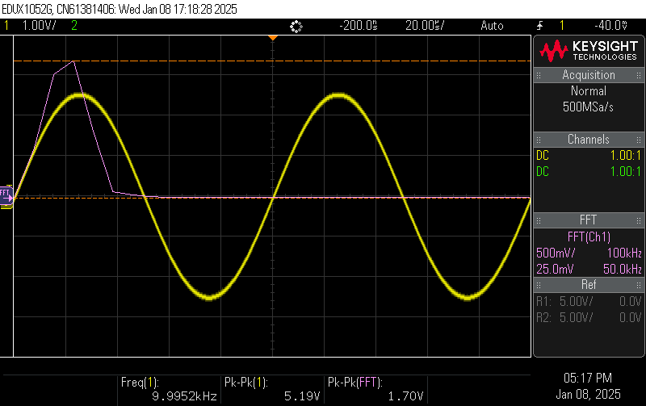

FFT of the Sine Wave

* Part 2:

Signal Frequency = 10 kHz

RC Combination of Filter = 1 MΩ, 10 pF

Cutoff Frequency = 15915 Hz

|  |  |  |  |  |  |
| --- | --- | --- | --- | --- | --- |
|  | 1st Harmonic Strength (dB) | 2nd Harmonic Strength (dB) | 3rd Harmonic Strength (dB) | 4th Harmonic Strength (dB) | 5th Harmonic Strength (dB) |
| w/o Filter | 6.25 | -2.818 | -7.2 | -10.642 | -12.832 |
| w/ Filter | -10 | -28.125 | -36.25 | -42.5 | -46.25 |

FFT of Square Wave w/o Filter, with strength of 2nd harmonic being measured

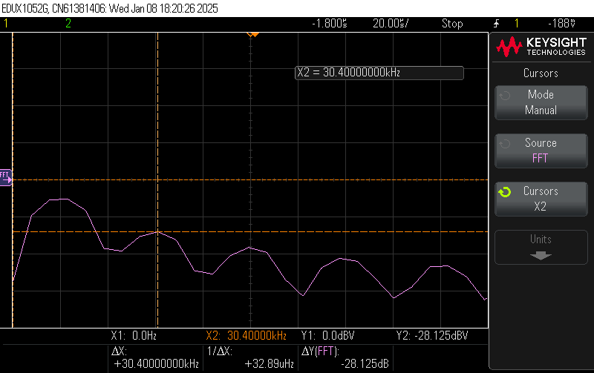

FFT of Square Wave w/ Filter, with strength of 2nd harmonic being measured.

* Result:

The effect of Probe factors and OSC factors were studied. The effect of a low-pass filter on the FFT of a signal was also studied.

The low-pass filter greatly reduces the strength of the 2nd and higher harmonics, since those frequencies are above the cutoff frequency of the RC circuit.

Experiment 2:

* Objective:

To measure the capacitance across the probes of the DSO.

* Components Used:
  + DSO
  + Resistor
  + Capacitor
  + Breadboard
  + Jumper Cables
* Circuit Diagram:

* Procedure:
  1. Assemble an RC Circuit with suitable values for the resistor and the capacitor. Calculate the theoretical time constant of the circuit.
  2. Generate a suitable square wave in the DSO according to the cutoff frequency of the RC Circuit.
  3. Measure the time constant of the circuit with the resulting voltage response across Vout
  4. Calculate the capacitance of the probes using the formula,

$C_{probe}=\frac{τ_{practical}-τ_{real}}{R}$

* Observation:

|  |  |  |  |  |  |
| --- | --- | --- | --- | --- | --- |
| S.no | Cload (pf) | Probe Factor | Calculated Time Constant(µs) | Measured Time Constant (µs) | Cprobe (pf) |
| 1. | 100 | 1 | 1 | 1.96 | 96 |
| 2. | 100 | 10 | 1 | 1.25 | 25 |
| 3. | 27 | 1 | 0.27 | 1.26 | 99 |
| 4. | 10 | 1 | 0.1 | 1.1 | 100 |

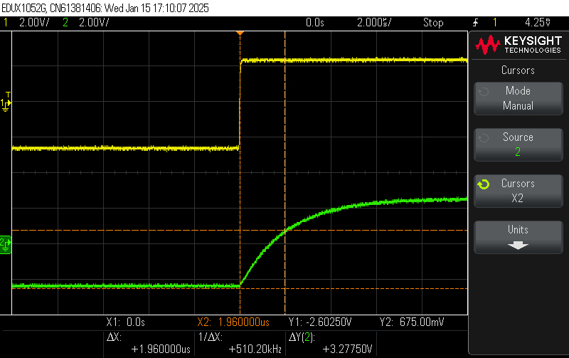

Measurement 1

Measurement 2

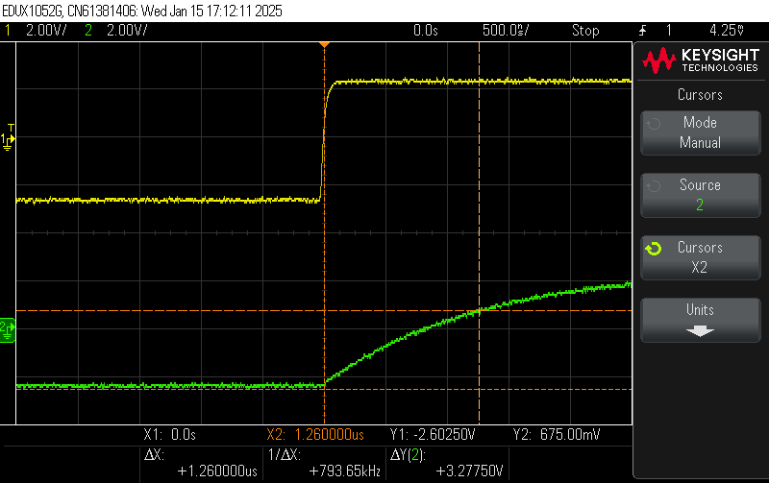

Measurement 3

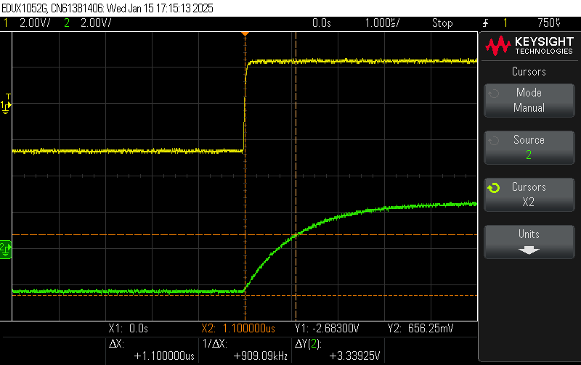

Measurement 4

* Result:

The capacitance across the probes of the DSO in different settings was measured.

The probe has lesser capacitance in the 10x factor than in 1x factor. So, it follows that 10x factor is more accurate than 1x.

Experiment 3:

* Objective:

To observe the charging and discharging behavior of 2 RC circuits in series.

* Components Required:
  + - DSO
    - Resistors
    - Capacitors
    - Breadboard
    - Jumper Cables
    - Switches
  + Circuit Diagram:

* Procedure:
  + 1. Assemble the RC circuits as shown in the circuit diagram above. The resistance values and the capacitor values should be equal, i.e., R1 = R2 and C1 = C2.
    2. Connect the probes of the DSO across the capacitors C1 and C2 to measure the voltage across them.
    3. Close switch S1 and open S2
    4. Generate a square wave in the DSO and connect it to the circuit
    5. Measure the time taken for C1 to charge fully.
    6. Generate a DC Voltage in the DSO and connect it to the circuit across V1.
    7. Once C1 is fully charged, open S1 and close S2 and measure the time taken for the circuit to reach a steady state.
    8. Repeat for another value of resistances.
  + Observation:
    1. Charging:

|  |  |  |  |  |  |
| --- | --- | --- | --- | --- | --- |
| S. No | Resistance R1 (kΩ) | Capacitor C1(µf) | Vp Initial (V) | Vp Final (V) | Time to Reach Steady State (ms) |
| 1. | 100 | 1 | 0 | 1.829 | 500 |
| 2. | 10 | 1 | 0 | 1.99 | 58.7 |

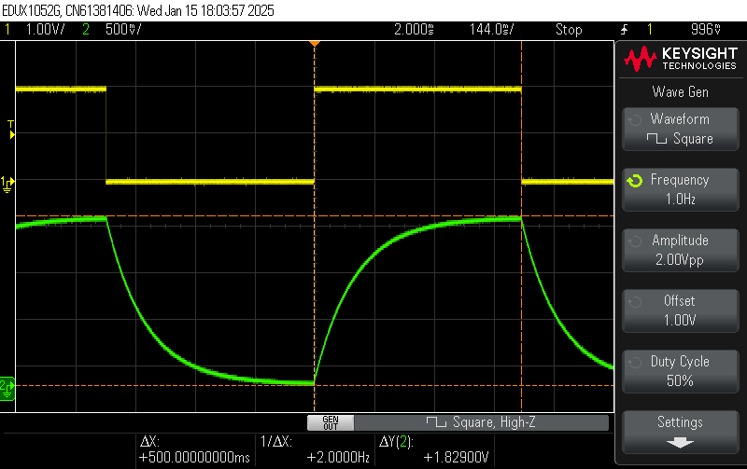

Measurement 1

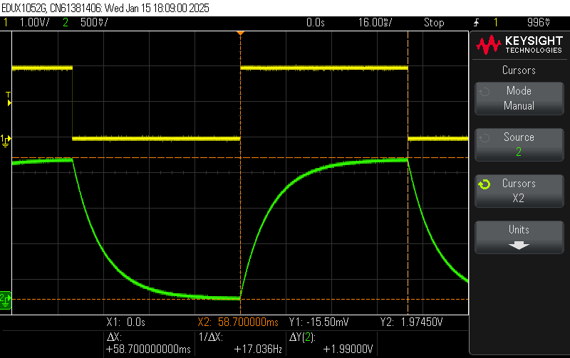

Measurement 2

* + 1. Discharging:

|  |  |  |  |  |  |  |  |  |
| --- | --- | --- | --- | --- | --- | --- | --- | --- |
| S. No | Initial DC Voltage (V) | Resistance R2 (kΩ) | Capacitor C2 (µf) | Vp Initial (V) | Vp Final  (V) | Vq Initial  (V) | Vq Final  (V) | Time to Reach Steady State (s) |
| 1. | 2 | 100 | 1 | 1.97 | 0 | 0 | 0.8 | 4.36 |
| 2. | 2 | 10 | 1 | 1.98 | 0 | 0 | 0.96 | 1.565 |

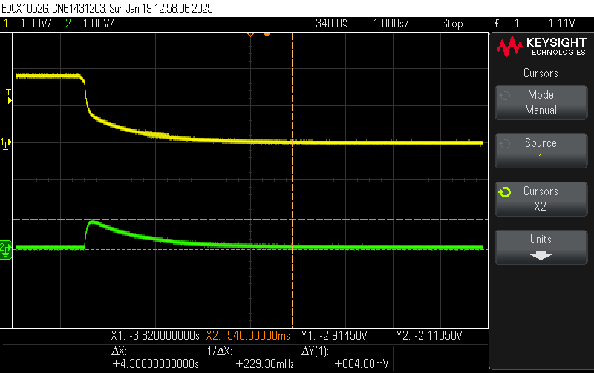

Measurement 1

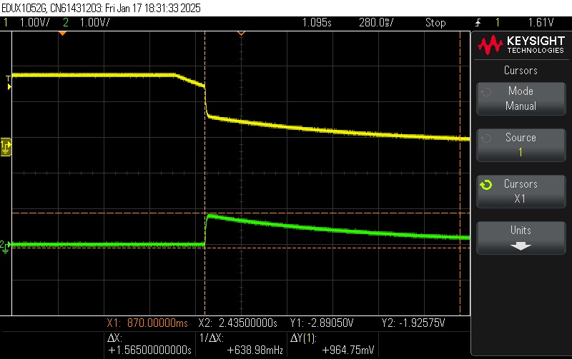

Measurement 2

* + Result:

The charging and discharging behavior of 2 RC circuits in series have been observed.

The time taken to reach steady state is directly proportional to the value of the resistance.

Experiment 4:

* Objective:

To obtain the I-V characteristic curve of a P-N junction diode.

* Components Used:
  + - DSO
    - Diode
    - Resistor
    - Breadboard
  + Circuit Diagram:

* Procedure:
  + 1. Assemble a diode-resistor circuit as shown in the figure above.
    2. Connect the probes of the DSO across the resistor.
    3. Generate a Sine wave in the DSO and apply it across the circuit and obtain the I-V graph of the diode in the DSO.
    4. Find the cut-in voltage of the diode and the current at that instant using the formula,
 $$I=\frac{V_{cut-in}}{R}$$

   5. Reverse the direction of the diode and repeat.
  + Observation:

Resistance Value = 10kΩ

* + 1. Forward Bias:

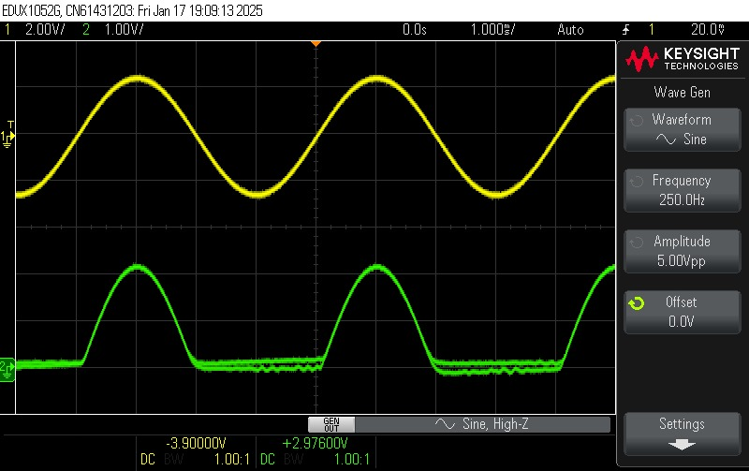

Voltage Across Resistance

I-V Curve

Cut-in Voltage = 325 mV

Current = 32.5 µA

* + 1. Reverse Bias: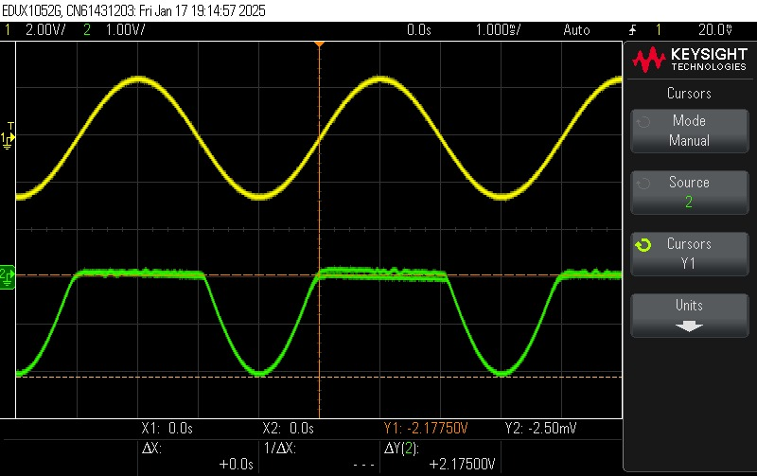

Voltage Across Resistance

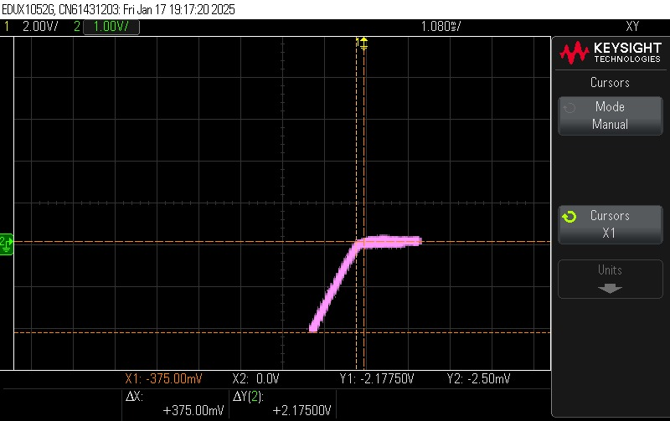

I-V Curve

Cut-in Voltage = 375 mV

Current = 37.5 µA

* Result:

The I-V characteristic curve of the given diode has been studied.